1. Install Jenkins

2. Create the task which will perform the following:

* Clone the project
* Launch tests from the project in Java directory with the help of mvn test goal

Result similar to first practical task

3. Set up build triggers:

* Launch tests not later than 5 minutes after committing in git
* Every workday at midnight

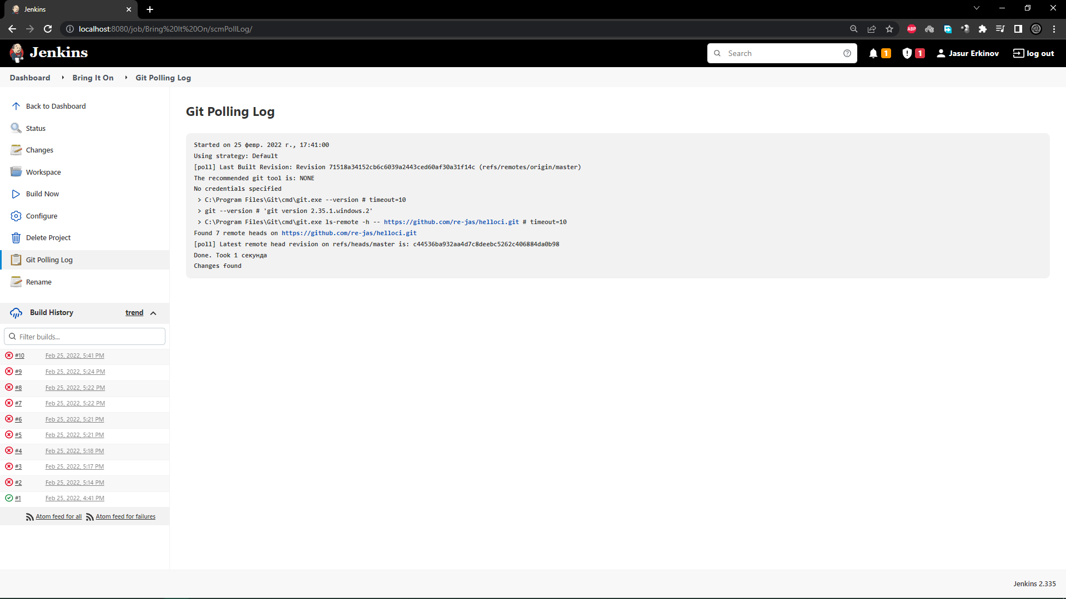

First I didn’t set schedule because wanted to check was it working or not. So, I made a commit and after one minute “Poll SCM” trigger worked and build was made.

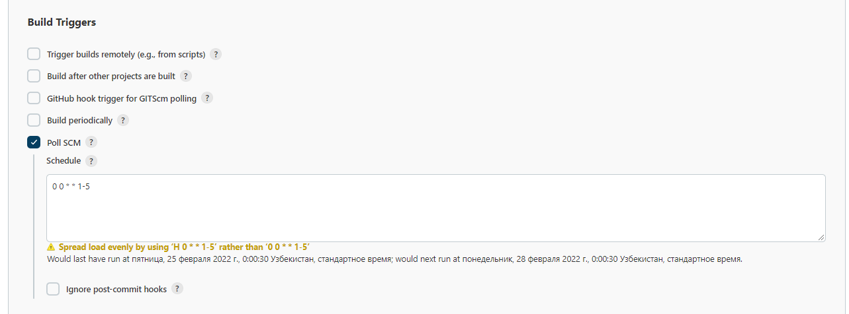

4. Publish “Java\target\surefire-reports\com.github.vitalliuss.helloci.AppTest.txt” file as an artifact

